Q1. Write a shell script to read the value of two variables x and y and perform all basic calculator operation.

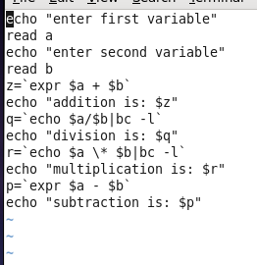

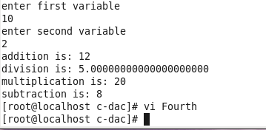

Q2. Write a shell script to read the value of 2 variables and swapped values of x and y

 and z=x+100.

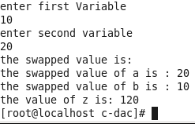

Q 3.Write a shell program to read users firstname, middlename and last name in three variable. And print the fullname. Enter the basic salary of the user and print his total salary by giving 70%basic and 30%DA.

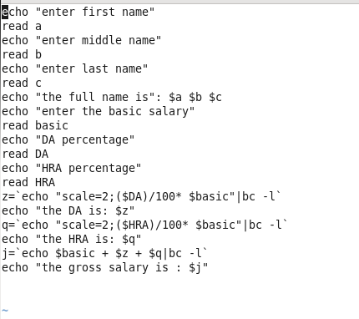

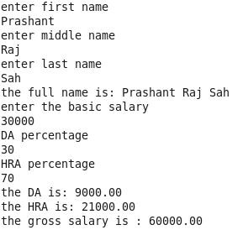

Q 4. . Read the marks of 5 subject of a student and print the percentage.

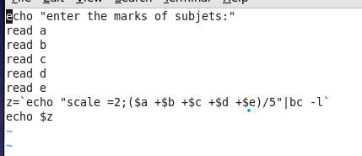

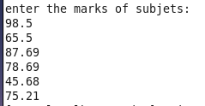

Q5. WSS to enter the temperature in Fahrenheit and convert to Celsius and vice versa.

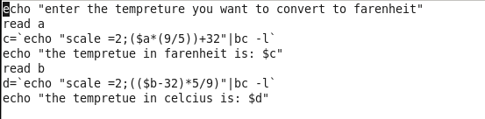

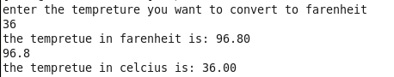

Q6.Write a shell script find the greater number among two variables.

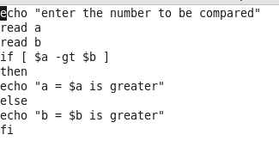

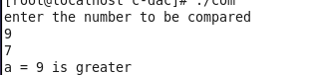

Q7. find the largest among three variables entered by user.

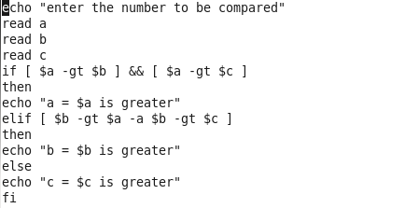

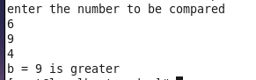

Q8. enter a number and the check the number is an even number or odd number.

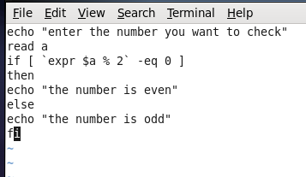

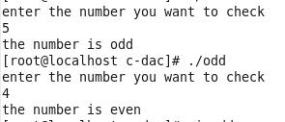

Q9. Enter the basic salary .

If the basic salary is within 2000 to 5000 then his DA is 50% of basic and hra is 10%

If the basic salary is within 5001 to 15000 then his DA is 60% of basic and hra is 20%

If above 15000 then then his DA is 70% and hra is 30%

Display the total salary of the employee.

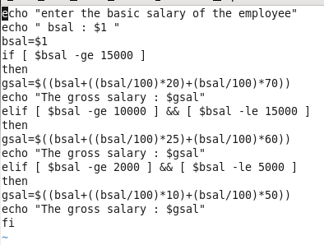

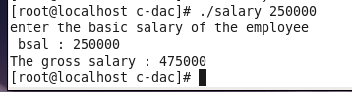

Q10. Enter the marks of 5 subjects of a student

Find the percentage and the grade of the student

If his percentage is 90 to 100 then grade is A+

If his percentage is 80 to 89 then grade is A

If his percentage is 70 to 79 then grade is B+

If his percentage is 60 to 69 then grade is B

If his percentage is 50 to 59 then grade is C

Below 50 is fail.

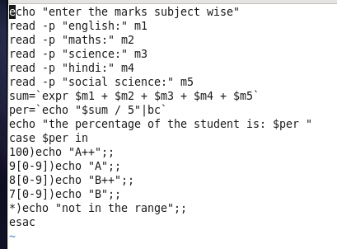

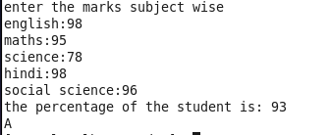

Q11. enter two strings. Check they are equal or not .

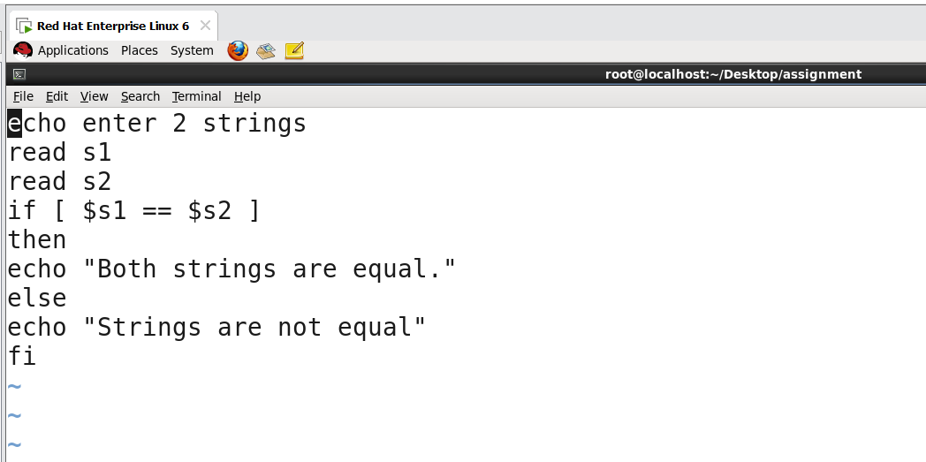

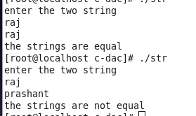

Q12. Read a string value and check if is a palindrome string or not.

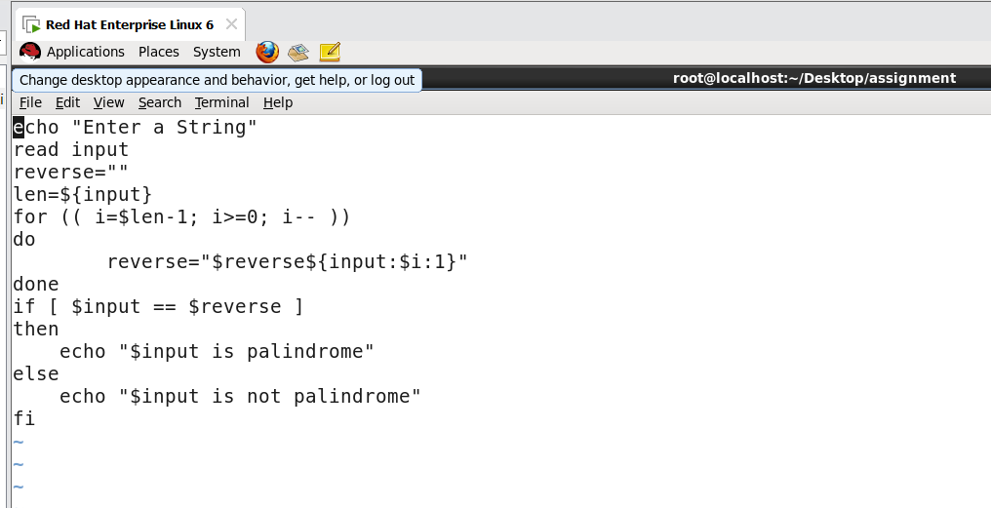

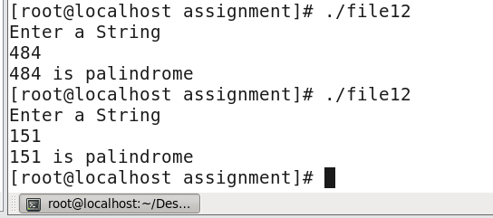

Q13. Write a shell script to enter a file name. then display the content.

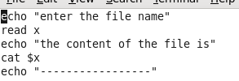

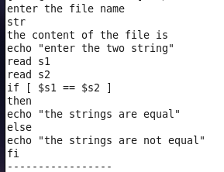

Q14. Write a shell script to enter a file name and check the file has content or it’s a blank file

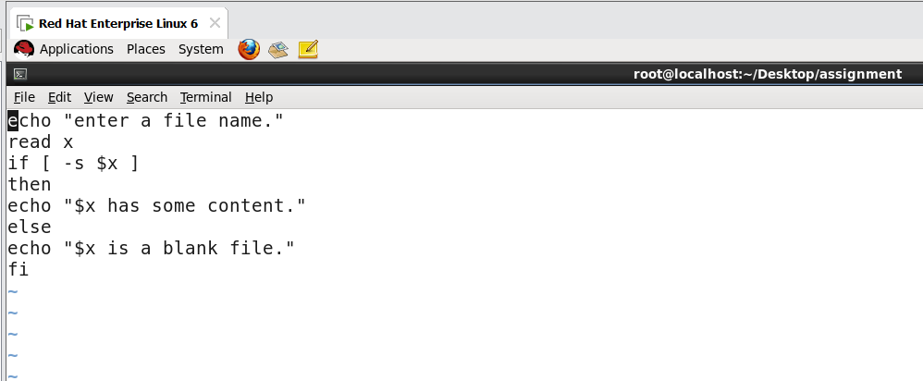

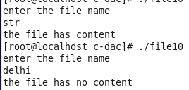

Q15. Write a shell script to check whether the user entry is a file or directory.

If it’s a file, then check its blank or not. If black add some content, otherwise display the content.

If it is a directory then display the directory structure.

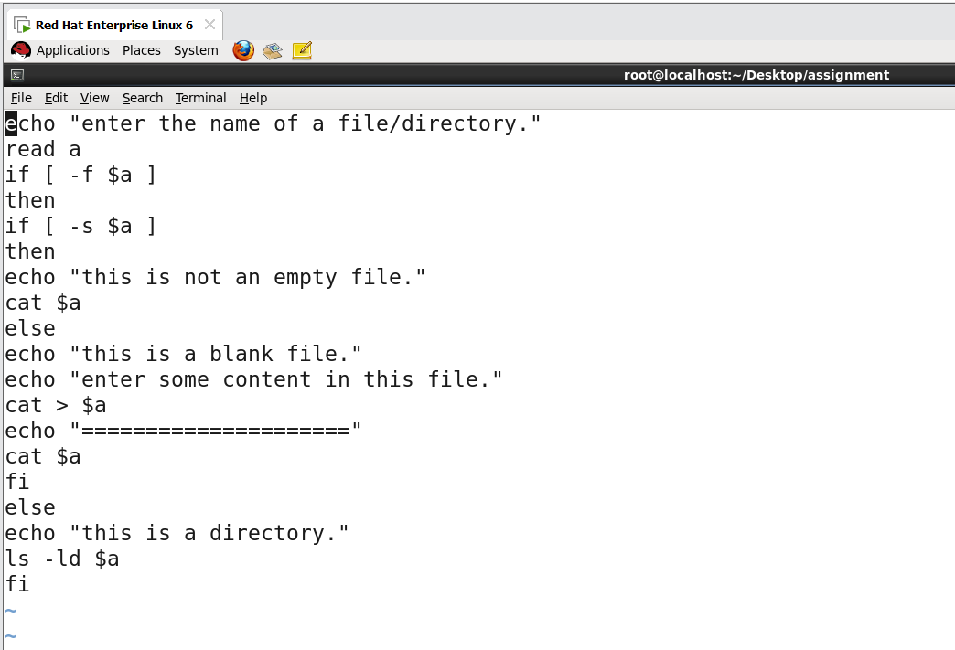

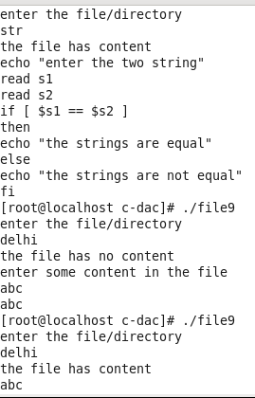

Q16. WSS to check whether a file entered by the user has execution permission or not

If not , then assign the permission.

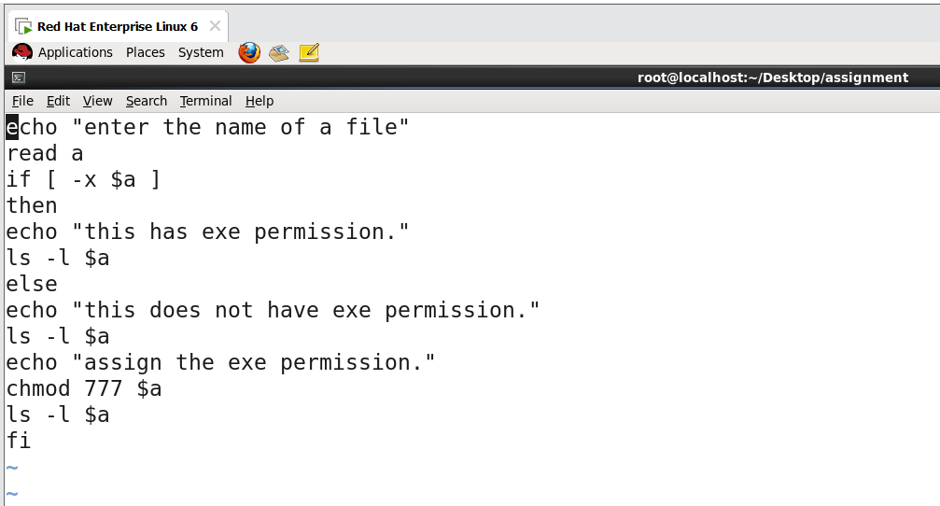

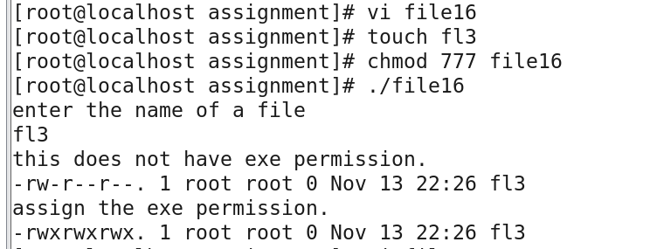

Q17. WSS to check whether a file entered by the user has all three permission on user or not??

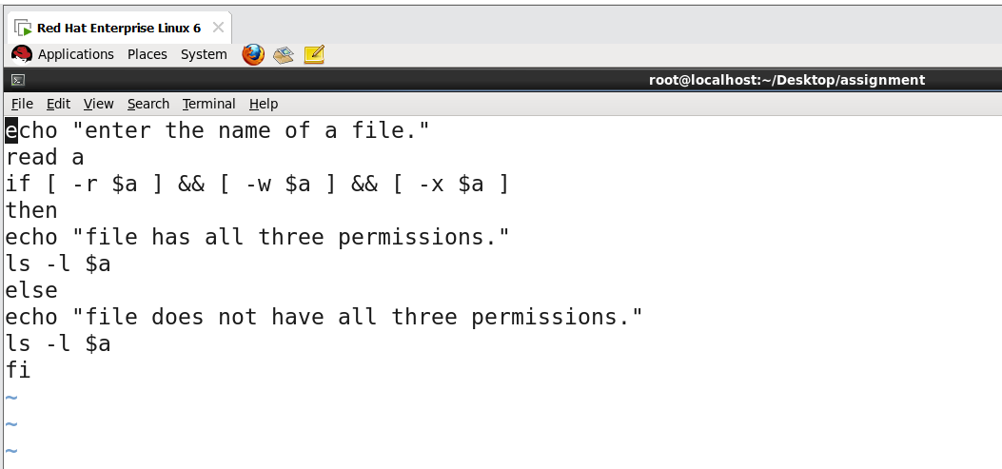

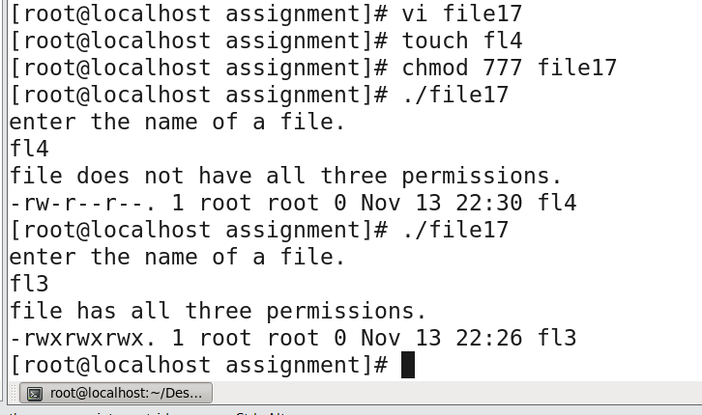

Q18 Read two no. User can enter any no between 1 to 5 for the following operation

1 for addition of 2 no

2. subtraction

3 multiplications

4. division

5. modulus

